**Wheelchair Accessible Businesses in London**

1. **Design & Approach**

This section focuses on wheelchair accessible businesses, which can reflect the living convenience for disabled people who travelling around by wheelchair. For nearly 1 in 5 people are disabled in the UK, wheelchair accessibility is not only important for disabled people, but also beneficial for the owner of a business so that the target market can be enlarged a lot (Euan's Guide, 2019). To visualize and analyze the current situation about wheelchair accessible businesses, data from Yelp – a famous review forum is being used. London, which has the most businesses in the UK as the capital, has been chosen as the case.

* 1. **Objectives**

The points listed below are the main objectives for this part:

(1). Draw a map of the current wheelchair accessible businesses in London so that the distribution can be seen straightforwardly;

(2). Create a search function that people can find their positions and read detailed information about businesses around easily;

(3). Investigate the distribution of wheelchair accessible businesses in each borough of London to analyse the spatial unfairness;

(4). Calculate the percentage that wheelchair accessible businesses take up in all businesses in London to show the emphasis degree of business wheelchair accessibility.

**1.2. Methods**

HTML is utilized to do the visualization based on Yelp API, Mapbox GL JS and CanvasJS.

**1.2.1. Data acquisition and processing**

(1). Python: python is used to retrieve Yelp (2019a) business search responses by adjusting Sigma Coding’s (2018) tutorial code. By setting ‘limit’ and ‘offset’ values learnt from london-rhythms’ (2018) Github code, this endpoint can return up to 1000 businesses. For the quantity of any category of wheelchair accessible business in London is less than 1000, complete responses can be returned. Every category of business response is transferred into csv after data cleaning and reconstruction;

(2). Excel: according to Yelp (2019b) Category List, there are 16 categories of wheelchair accessible businesses available in London. To reduce the number of categories, some similar categories are combined together in Excel. Finally, the csv files of 8 main categories are merged: Restaurants, Food, Shopping, Travel (Event Planning & Event Services + Hotel & Travel), Leisure (Sports & Leisure + Arts & Entertainment + Education), Night Life, Beauty & Health (Beauty & Spas + Health & Medical), Local Services (Home Services + Local Services + Pets + Professional Services + Government & Public Services);

(3). ArcGIS: the csv files obtained in step 2 are imported to ArcMap and joined with London Boroughs shapefile (London Datastore, 2018) to calculate the quantity of businesses in each borough (figure 1). Then, a new borough shapefile with business attributes is exported;

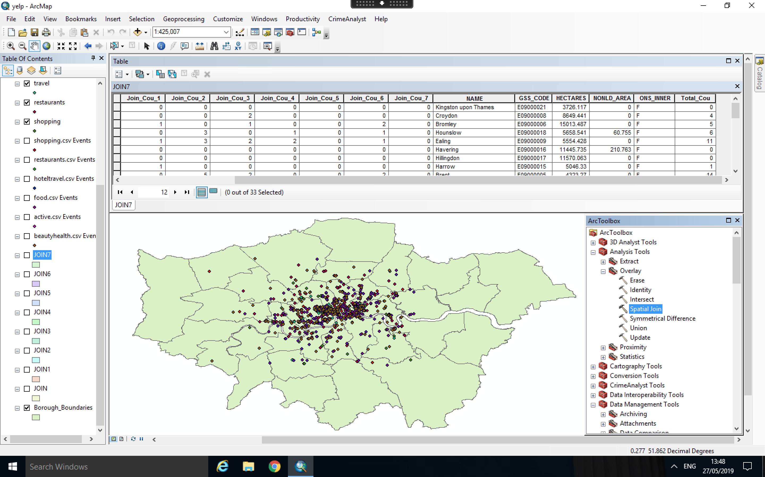

Figure 1. Join Business Points with London Borough Boundary Polygons in ArcMap

(4). Mapbox Tilesets: all csv files and the shapefile achieved above are uploaded into Mapbox as tilesets;

* + 1. **Interactive Website Construction**

(5). Tilesets in step 4 are added as layers in html script and buttons which can show and hide these layers are generated by modifying code in Mapbox (2019b) GL JS examples;

(6). The hover highlight effect for boroughs are built by altering the code teachers showed in week 3 practical;

(7). The search function is produced according to Mapbox (2019a) Geocoder;

(8). The popup for business points and boroughs is created based on solutions in StackExchange (2018);

(9). Charts are appended by changing code offered by canvasJS (2019).

1. **Results**

As the final website visualization shows (figure 2), from the map in the middle and the chart in the left, obviously, most wheelchair accessible businesses are located in the inner London. Especially in Westminster, the quantity of every type of business is several times than any other boroughs. It indicates that it’s unfair for disabled people who live in outer London for they have to travel a long time to arrive in the businesses which are marked as ‘wheelchair accessible’ in Yelp.

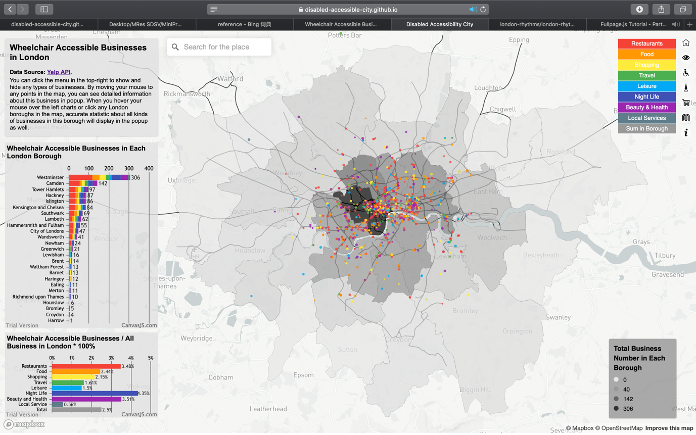

Figure 2. Final Website Visualization

By clicking the buttons in the top-right, we can show or hide the layer of every category of business. As we close all layers at first and display them one by one, we can see that restaurants are clustering in the West End and the East End of London. After open food layer, which includes cafes, groceries and so on, we can find that the location of them is very similar to restaurants. For shopping stores, such as shopping centers and bookstores, again, they love to be the neighbors with restaurants. However, for hotels and other travel-related facilities, they are more likely to distribute in the boundary of high-density area of restaurants and shops. It makes sense because they want to be convenient to access restaurants and shops while they wish the environment is not so noisy (figure 3).

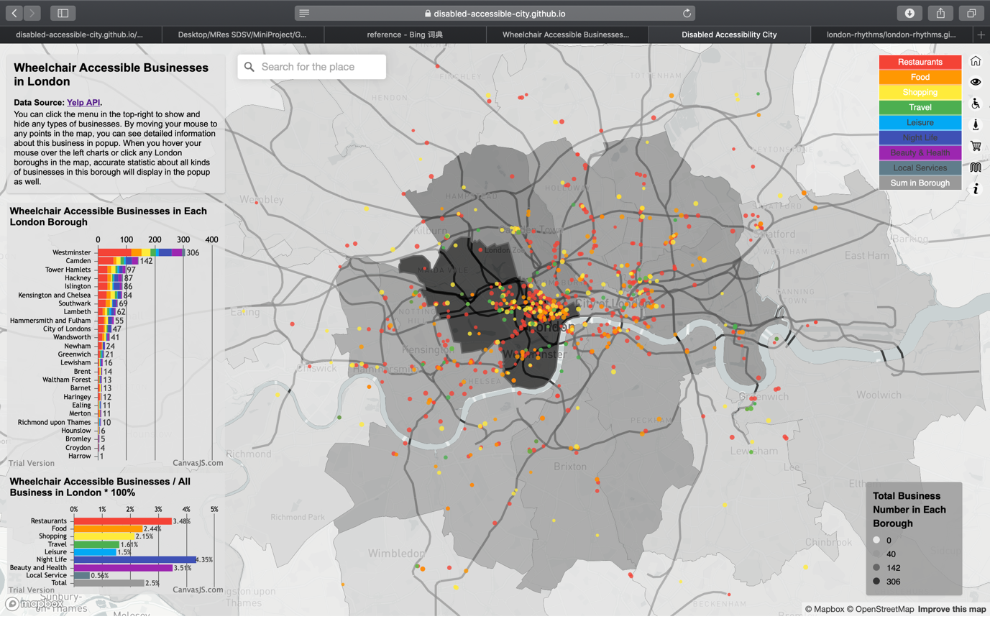

Figure 3. Distribution of Restaurant, Food, Shopping and Travel Businesses

In addition, when we close all other layers but only open travel layer (figure 4), we can find that almost every wheelchair accessible hotel is very close to tube lines so that more transportation convenience can be created for disabled people.

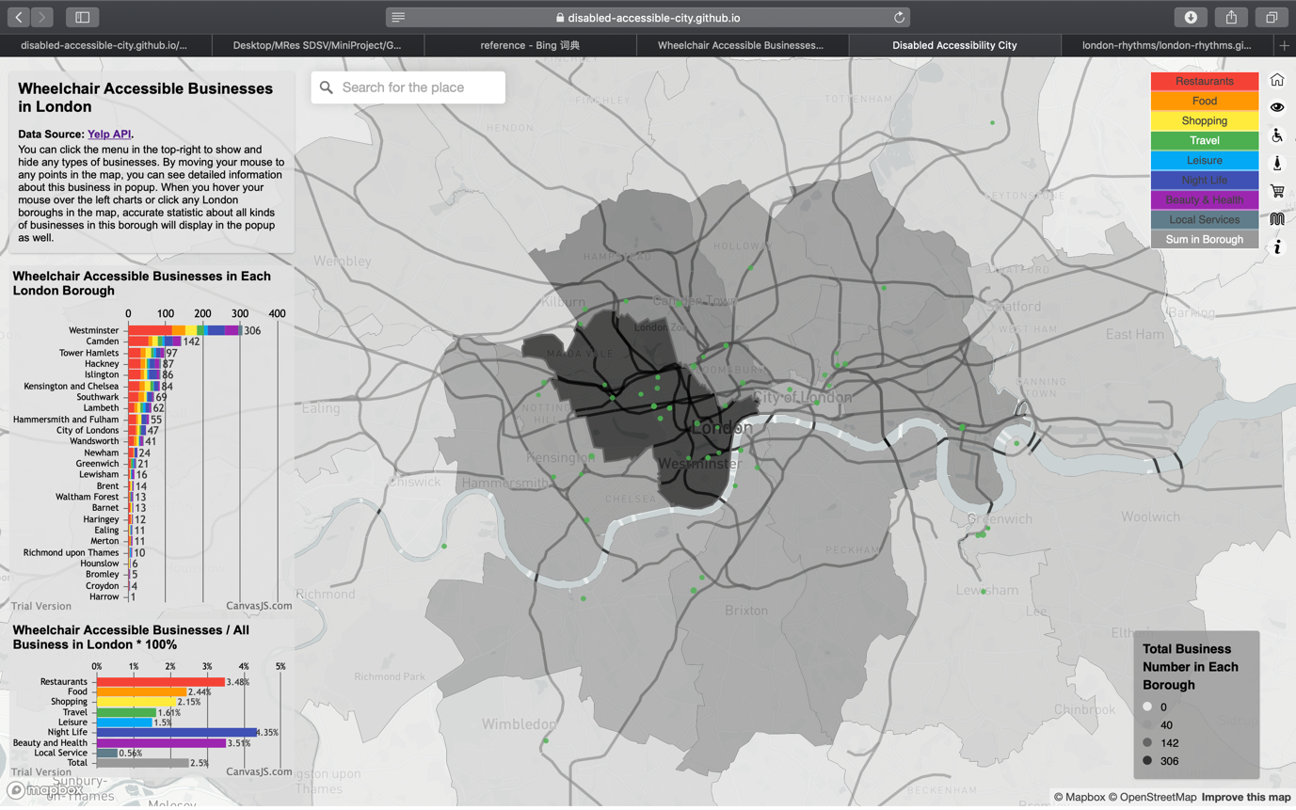

Figure 4. Distribution of Travel Businesses

For leisure facilities (figure 5), such as museums, theatres, gyms, they seem scatter more randomly in London.

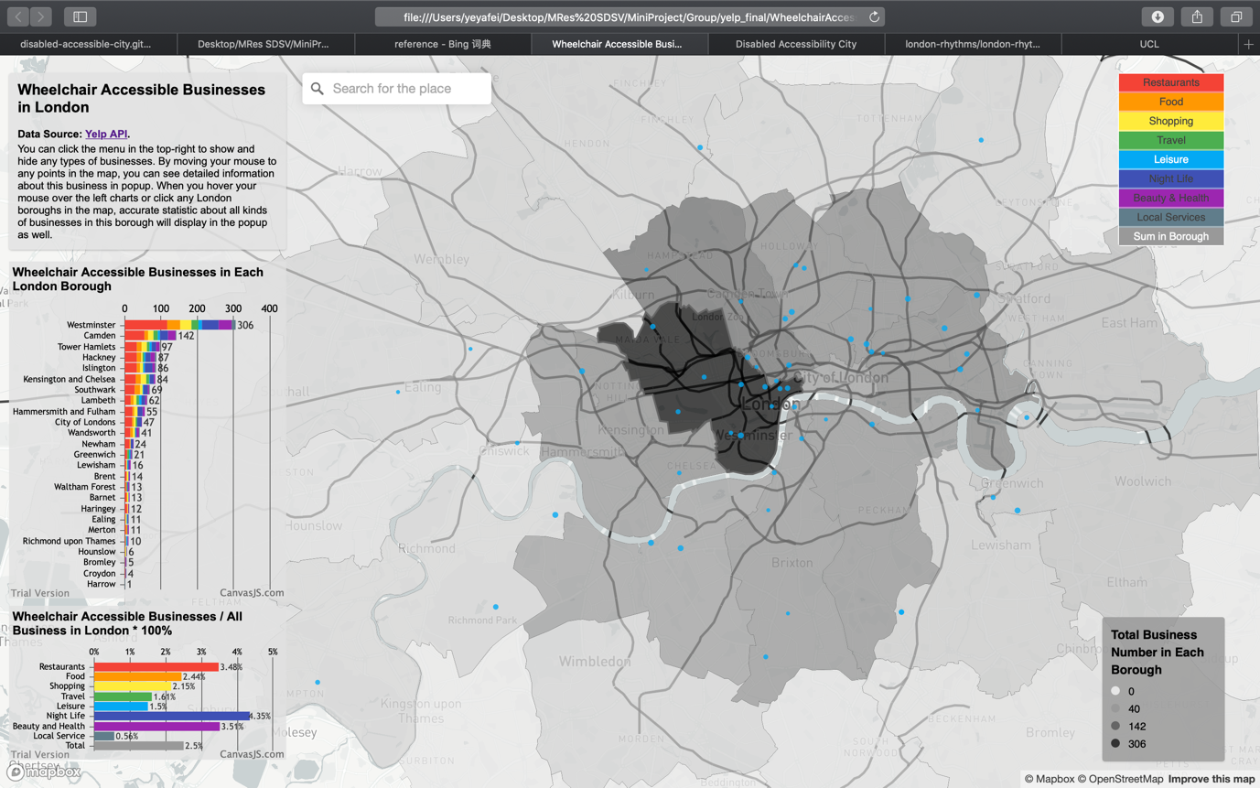

Figure 5. Distribution of Leisure Businesses

For night life facilities, such as pubs and bars, and beauty and health stores, such as barbers, skin care and massage, if we can remember the distribution of restaurants, they are quite similar (figure 6).

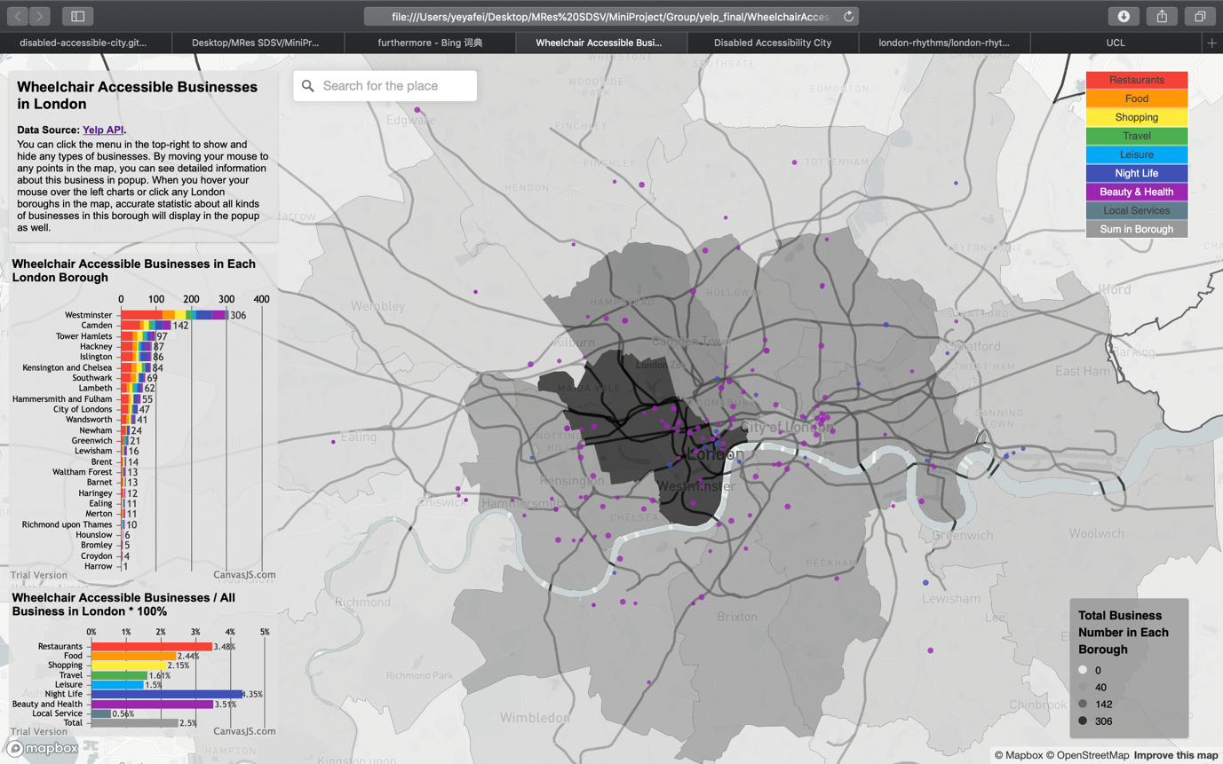

Figure 6. Distribution of Night Life and Health & Beauty Businesses

For local services, such as computer, phone, bike repair stores, they gather in oxford street and locate randomly in other area (figure 7). Based on these regulations we investigated, disabled people can seek out the place which fits their needs more quickly.

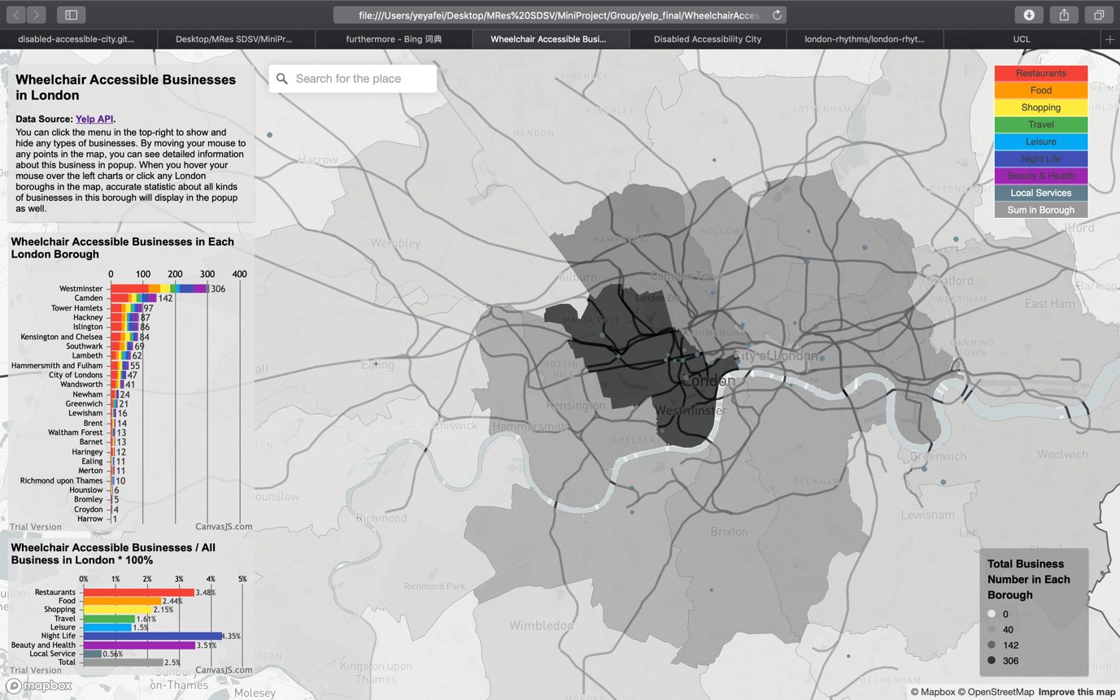

Figure 7. Distribution of Local Service Businesses

There is a search bar in the middle top as well, people can search for their locations and the map will zoom in to this place. Taking UCL as an example (figure 8), we type UCL and search, then the map will zoom in to UCL. If we want to seek for restaurants which is accessible for wheelchair, we just move the mouse to the red points around to see the popup which displays the name, picture, category, price level and rating scores of every business. Furthermore, the point radius has been set equal to rating score: higher the rating, bigger the points, so that we can find the most satisfied place rapidly.

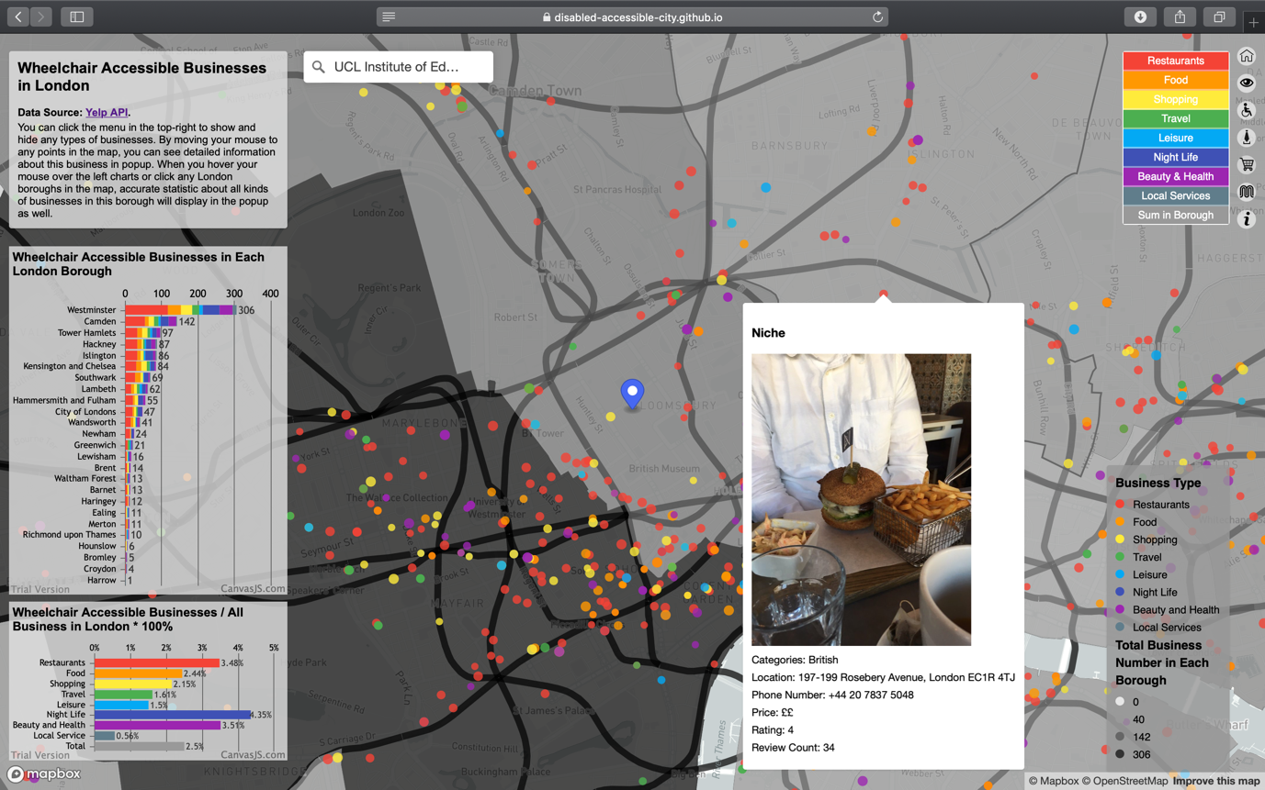

Figure 8. Search Function and Business Popup

By clicking each borough in the map (figure 9) or the charts (figure 10), we can see a popup with accurate numbers of businesses in this borough as well. As a result, we can learn the current situation of living convenience for disabled people in each borough of London more deeply.

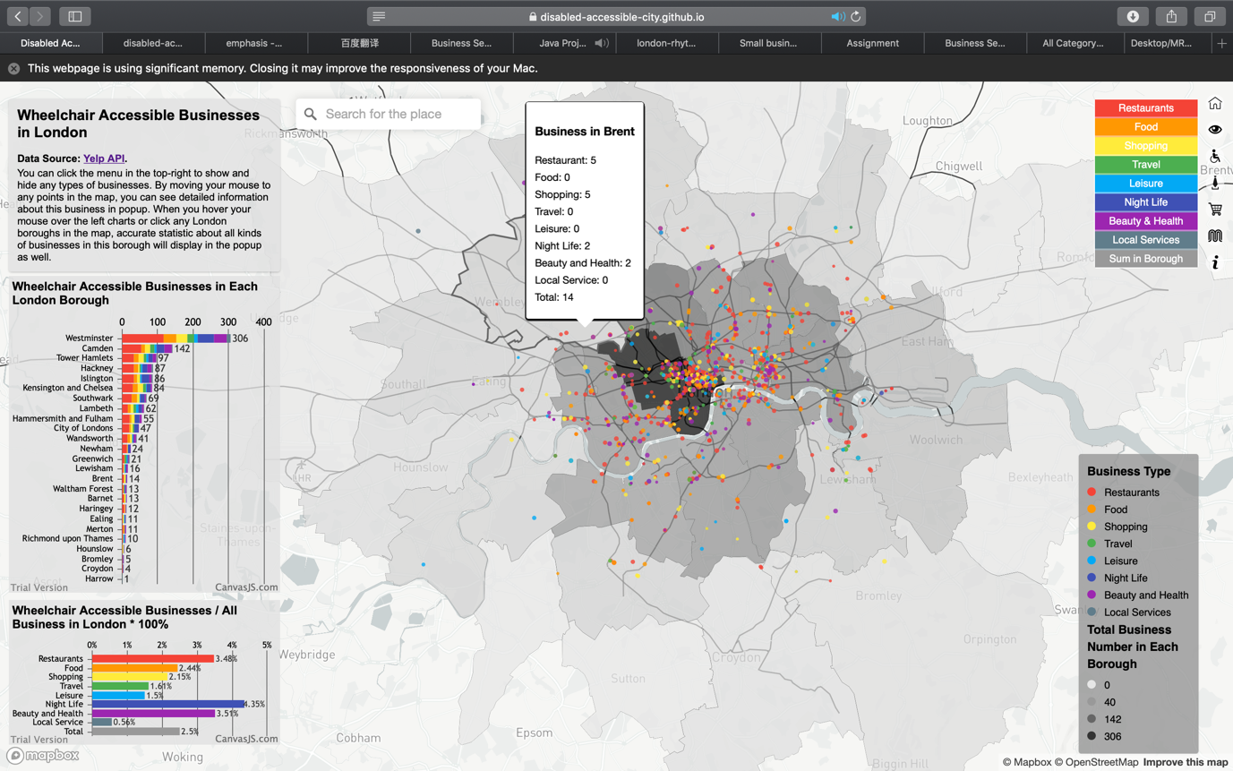

Figure 9. Borough Business Popup

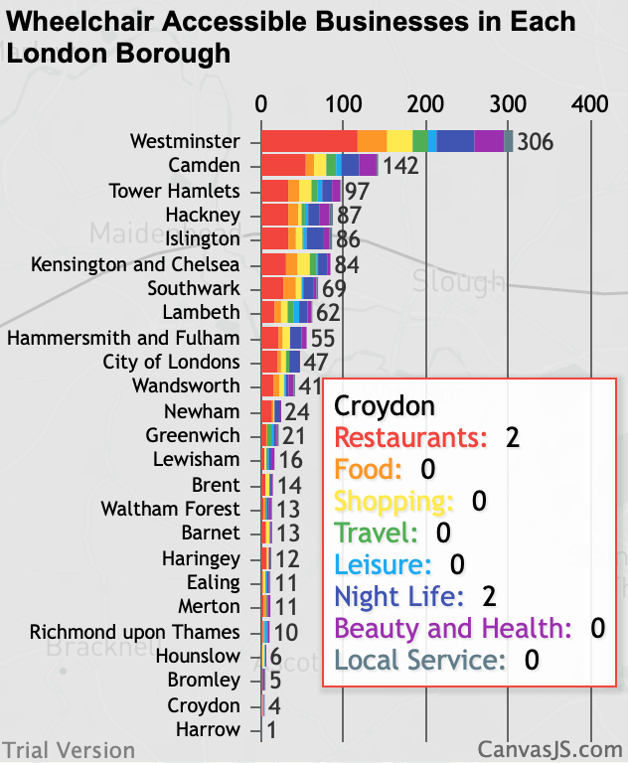

Figure 10. Stacked Histogram on Wheelchair Accessible Businesses in Each London Borough

The chart about the percentage of wheelchair accessible businesses in total quantities of each type of business in the bottom-left (figure 11) demonstrates that businesses in London generally pay little attention in disabled people. All kinds of businesses take up less than 5%, particularly for local service, which only takes up 0.56%.

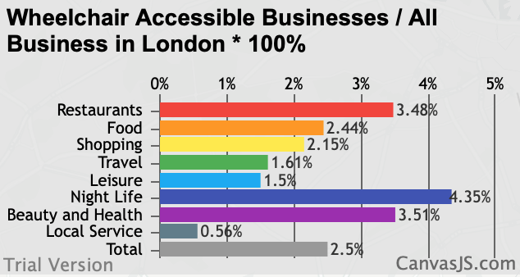

Figure 11. Histogram on Wheelchair Accessible Businesses / All Business in London * 100%

In conclusion, the current wheelchair accessible businesses situation in London is a little terrible. However, it may cause by the bias of data source.

**Bibliography**

CanvasJS, 2019. *jQuery Stacked Bar Charts & Graphs.* [online]. Available at: <<https://canvasjs.com/jquery-charts/stacked-bar-chart/>> [Accessed 14 May 2019].

Euan's Guide, 2019. *Small Businesses and Accessibility.* [online]. Available at: <<https://www.disabledaccessday.com/news/small-businesses-accessibility/?tag=useful+articles>> [Accessed 26 May 2019].

London Datastore, 2018. *Statistical GIS Boundary Files for London.* [online]. Available at: <<https://data.london.gov.uk/dataset/statistical-gis-boundary-files-london>> [Accessed 1 May 2019].

London-rhythms, 2018. *data processing.* [online]. Available at: <<https://github.com/london-rhythms/london-rhythms.github.io/tree/master/yelp/data%20processing>> [Accessed 1 May 2019].

Mapbox, 2019a. *Add a geocoder.* [online]. Available at: <<https://docs.mapbox.com/mapbox-gl-js/example/mapbox-gl-geocoder/>> [Accessed 14 May 2019].

Mapbox, 2019b. *Show and hide layers.* [online]. Available at: <<https://docs.mapbox.com/mapbox-gl-js/example/toggle-layers/>> [Accessed 1 May 2019].

Sigma Coding, 2018. *Using the Yelp API in Python (1).* [online]. Available at: <<https://www.youtube.com/watch?v=GJf7ccRIK4U>> [Accessed 1 May 2019].

StackExchange, 2018. [*Linking images to features in geojson layer popup using Leaflet?*](https://gis.stackexchange.com/questions/286245/linking-images-to-features-in-geojson-layer-popup-using-leaflet)***.*** [online]. Available at: <<https://gis.stackexchange.com/questions/286245/linking-images-to-features-in-geojson-layer-popup-using-leaflet>> [Accessed 14 May 2019].

Yelp, 2019a. */businesses/search.* [online]. Available at: <<https://www.yelp.com/developers/documentation/v3/business_search>> [Accessed 1 May 2019].

Yelp, 2019b. *Category List.* [online]. Available at: <<https://www.yelp.com/developers/documentation/v3/all_category_list>> [Accessed 1 May 2019].